Report Coursework 2

Candy Crush website

Description:

Candy Crush is a website that sells candies in different flavours. Customers can use the website to buy any amount of their favourite flavours.

Users of the website can always view its contents but, in order to purchase any item they will need to create an account or log in.

After creating an account, users can start to view the products from the “Home Page”. The website has a menu bar to select the preferred way to look at candies through the website pages. From the menu bar, users can select the "Best Sellers" or "All Products" in which the link will lead to a page that products are distributed according to the most sold items in the past month or, in case of all products page, customers can choose to view items according to categories of flavours. There is another sorting method added to the page that sort the items either according to price (in ascending or descending order) or alphabetically by the names. The second method to view products is to search by the product's name. If users know the name of the items, they can simply use the search field by entering the name of the candy and find if that name exists.

When users select an item they will be asked to choose the amount they want and use the option to add the items to the basket. When users have finished looking for candy, they can go to the basket from the menu bar where they will see all the items they have chosen. Users can edit the collected items in the basket and finally finish the payment process.

When users create an account all the buyers details such as name, address and contact details will be collected at the time. The only information that is not collected at the registration process is the payment details. So, when users are ready to complete their purchase items, the profile details will be generated to add to the order information from the database.

Employees account are added manually to the database by the admin for more security. After logging in, employees will be directed to the employees' page that has a different Uniform Resource Locator (URL) and functionality. Employees can add new items and check the stock availability of an item and to remove zero stock items from the website and, manage and arrange things according to orders.

Security Issues

1. Code injection:

is one of the most common attacks and very easy to detect. a website can be Attacked by entering a code in any user input text field to be executed as a command by its web server. For example, No-SQL injection. It is a type of code injection used to access a database by implementing malicious code to the input field which applies the command to the database to import the sensitive data or even delete data. To prevent code injunction developers for example have to Validate and sanitize inputs for all input fields in the website plus limit the use of special characters.

2. Cyber-Physical attack:

physical attacks mean hackers can access the computers system by physically accessing any devices connected to the internet for example, (the servers room) and implementing a USB or accessing the network by laptop. To prevent Cyber-Physical, companies need to raise awareness about physical security among their employees. physical measurements are important as well either by having security guards all around the facilities and implementing gates that allow one person at the time to enter the building instead of the normal card swapping doors that's allow for something like Tailgating to happen.

3. Cross-Site Scripting (XSS):

This type of attack is used against the application's users by injecting code, usually a client-side script into a web application's output. A text containing malicious code (usually in JavaScript) is inserted into a web page during a Cross-Site Scripting attack. When this input is returned to the user the input will be executed. To prevent the attack developers have to validate user inputs as strict as possible or based on what is the expected user input. Alternately, developers can encode data on output to prevent it from being interpreted as active content.

4. Security misconfigurations:

security misconfigurations happen when the system has unencrypted files

or poorly documented configuration that is inaccurately configured or left insecure. This means that the security settings are not defined, implemented, and default values are maintained.  To prevent the attack developers have to update the software version regularly and not leave the application to known vulnerabilities.

5. Denial-Of-Service (DOS) attack:

is an attack meant to shut down a machine or network, making it inaccessible to its intended users, by interrupting the device's normal functioning through flooding the systems and the servers, with requests to overload resources and stop the end user from getting access to the website. To prevent the attack developers have to make an incident response plan and use multiple servers which makes it harder for the attackers to attack all servers at the same time. Developers can detect DOS attacks by Monitoring and analysing network traffic.

Main Page

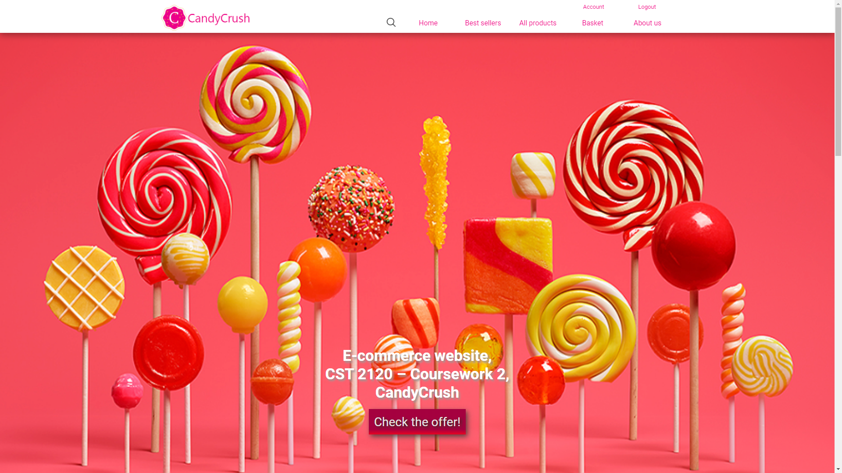

Main Page/bestsellers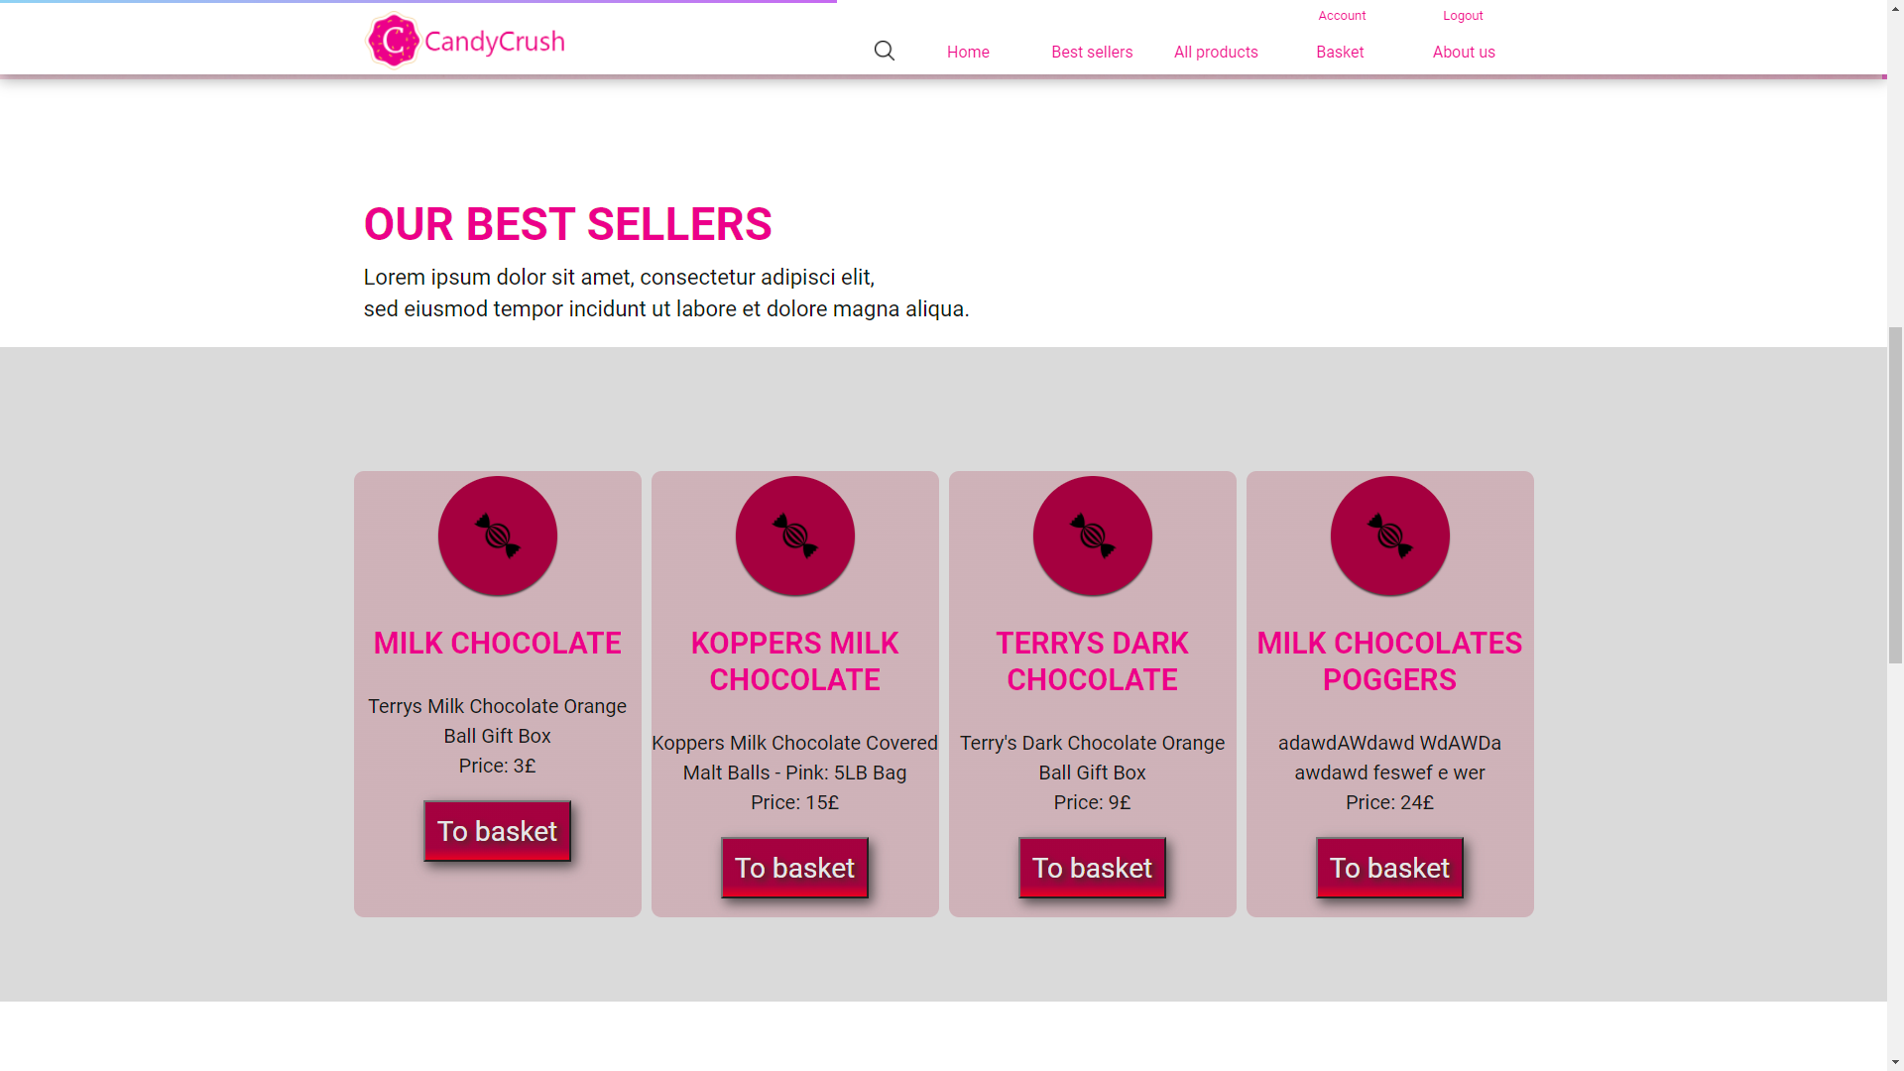

Main page/about us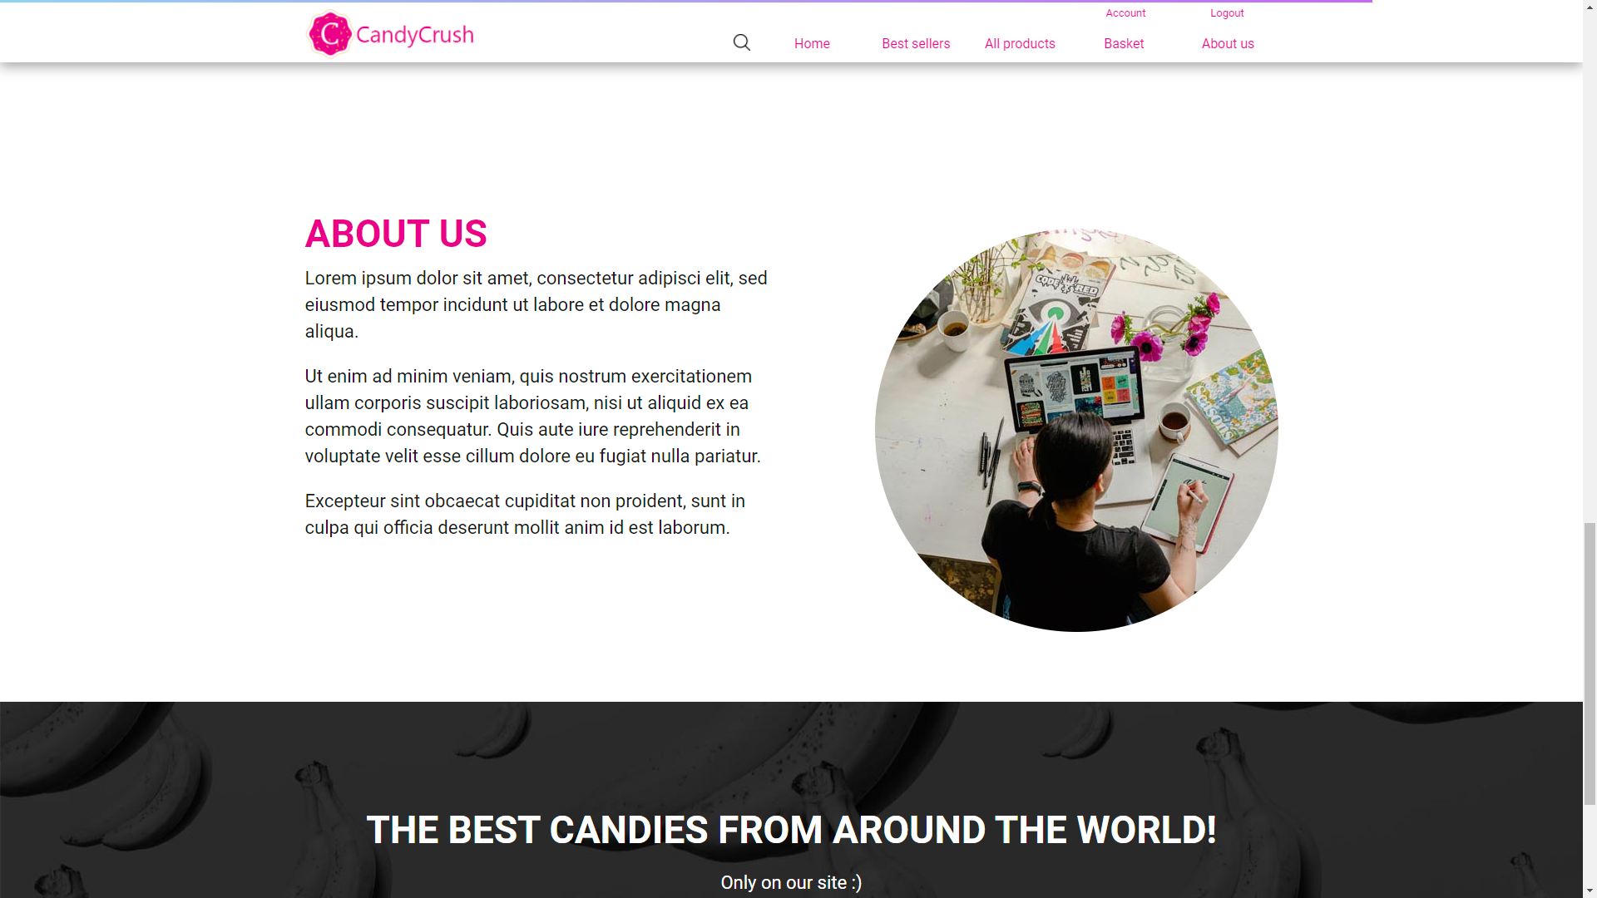

Main Page/footer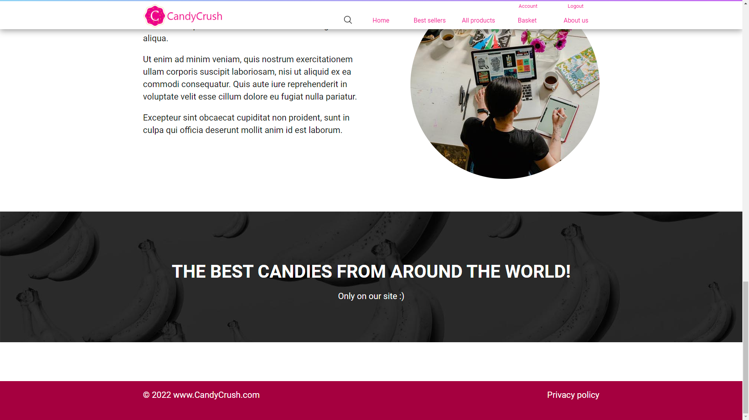

Search:

Search button at the top of every page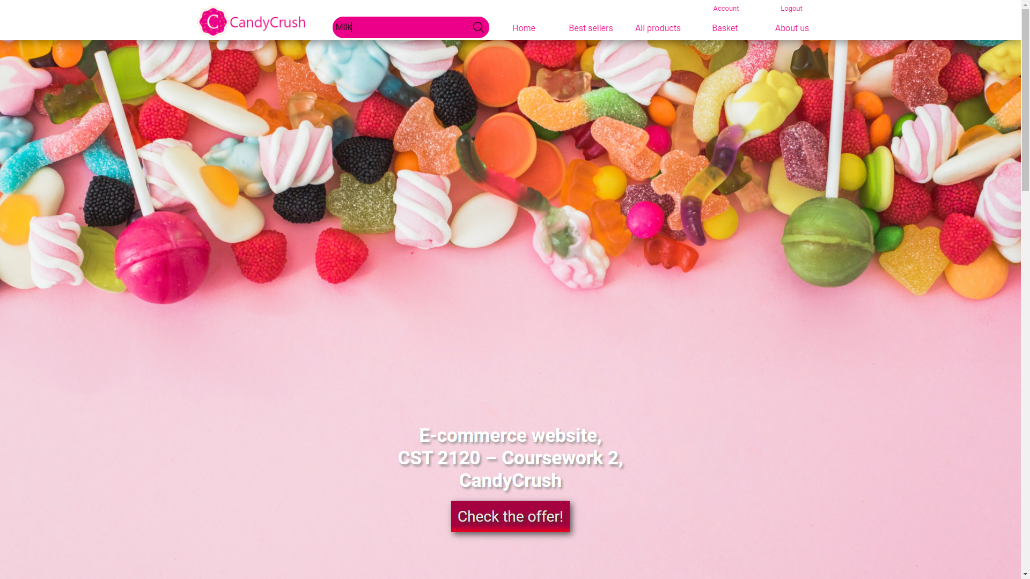

When button clicked or enter pressed open up search page

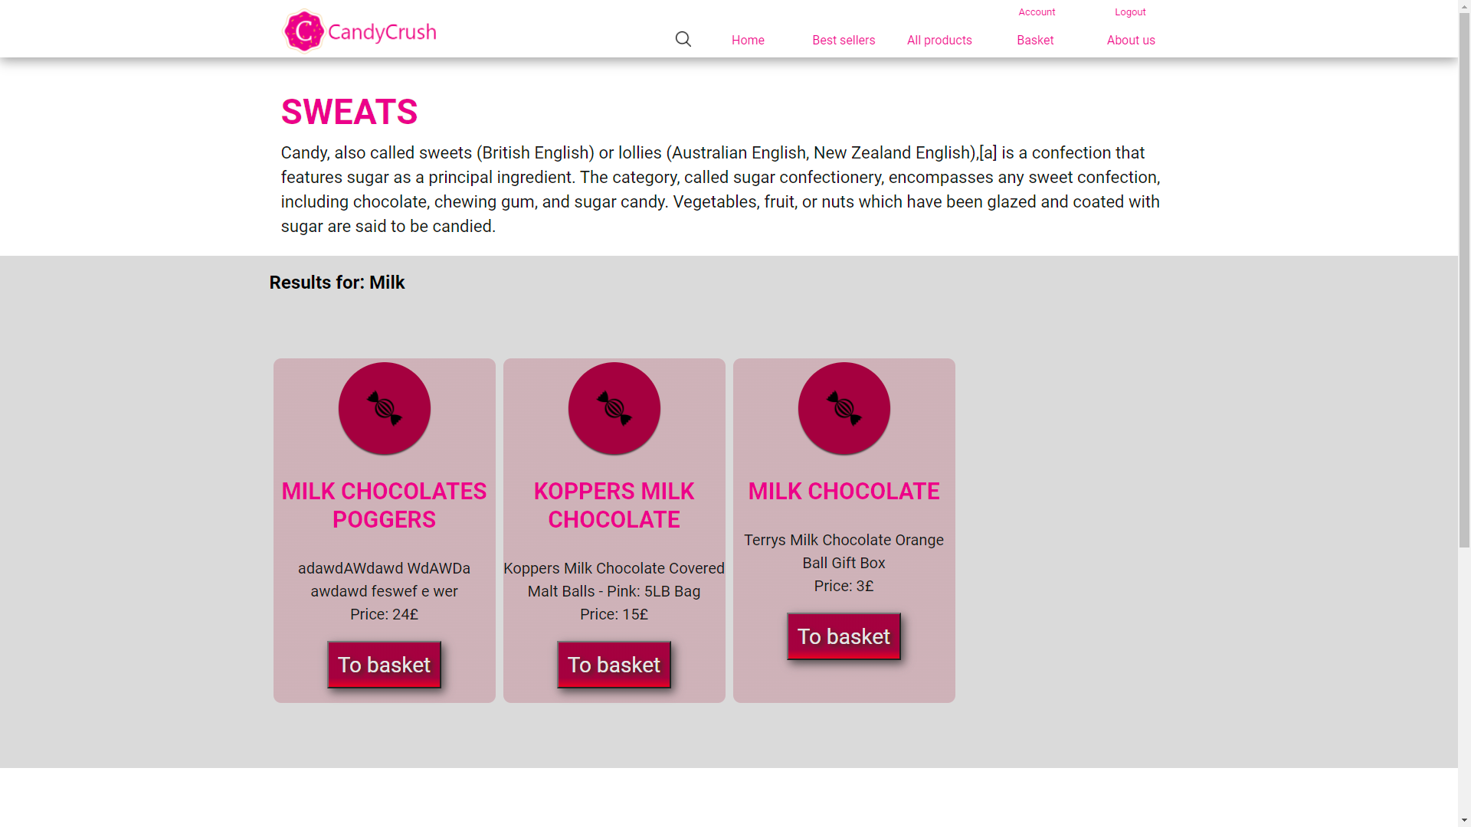

login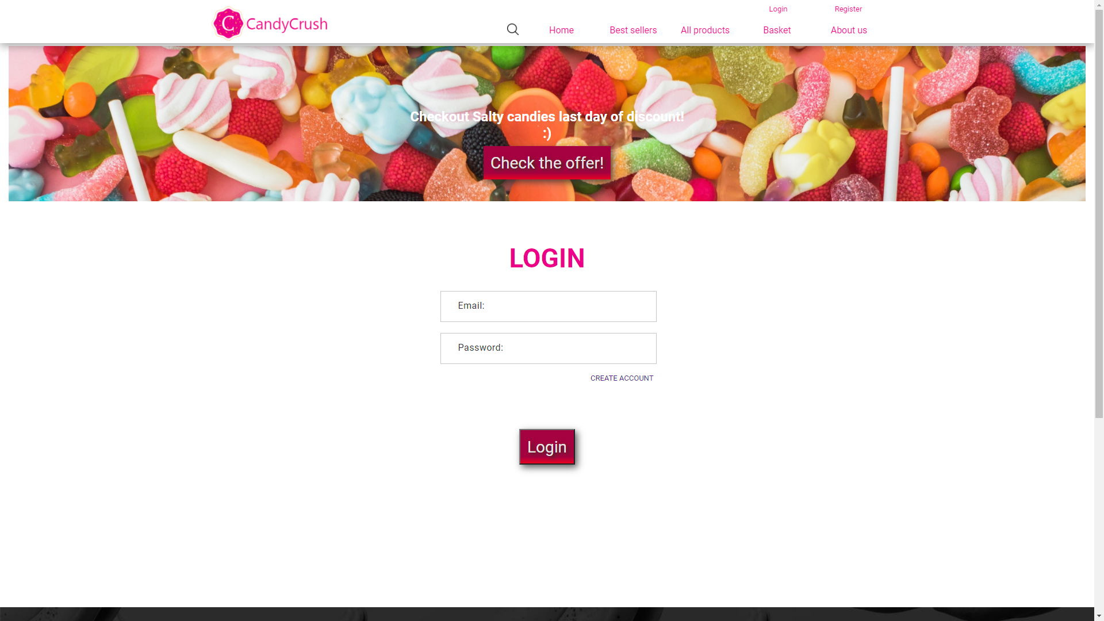

Register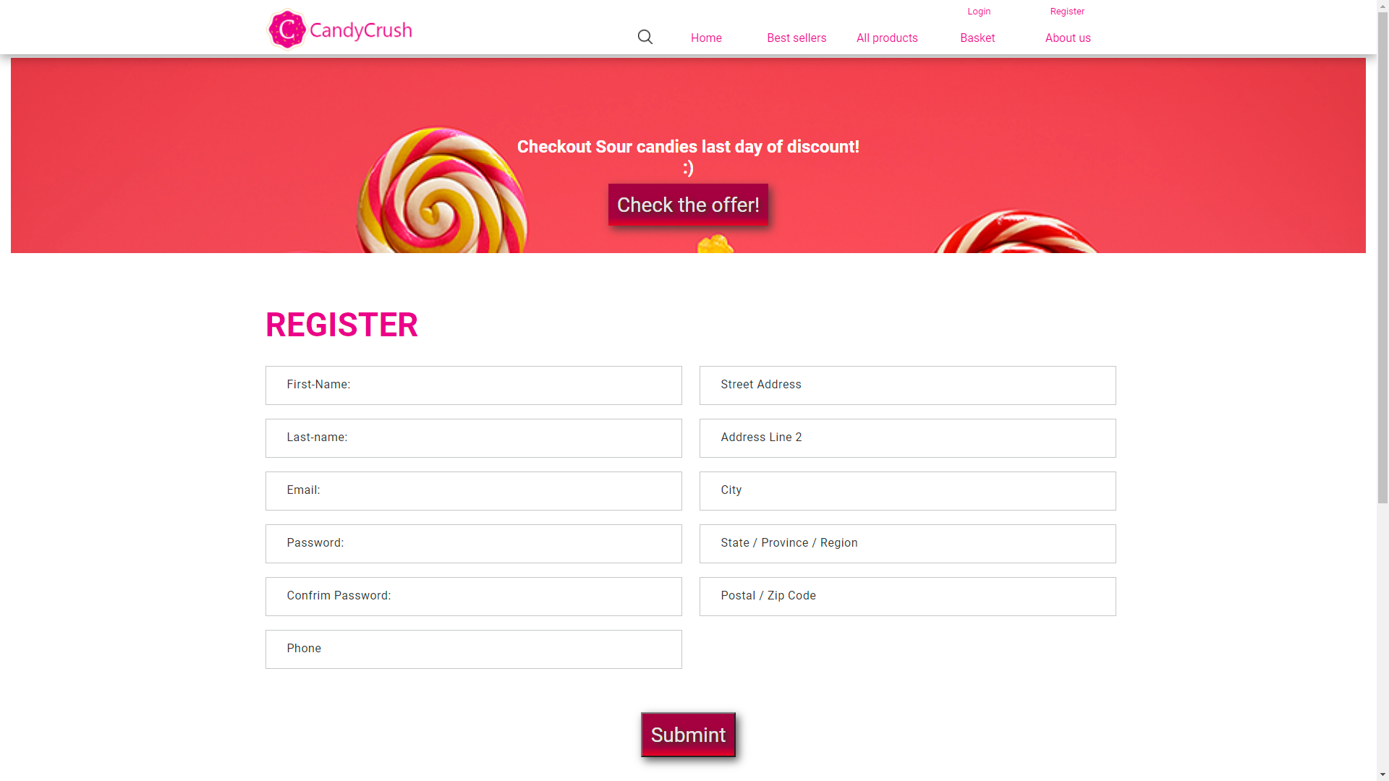

Products:

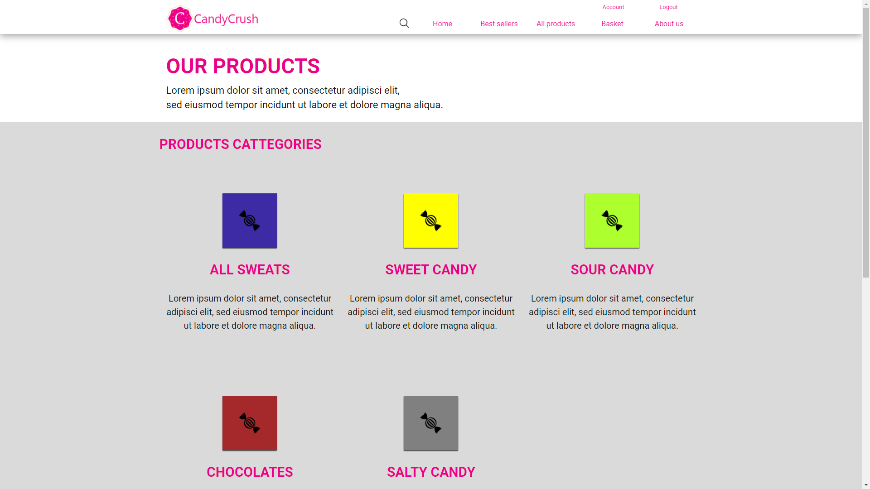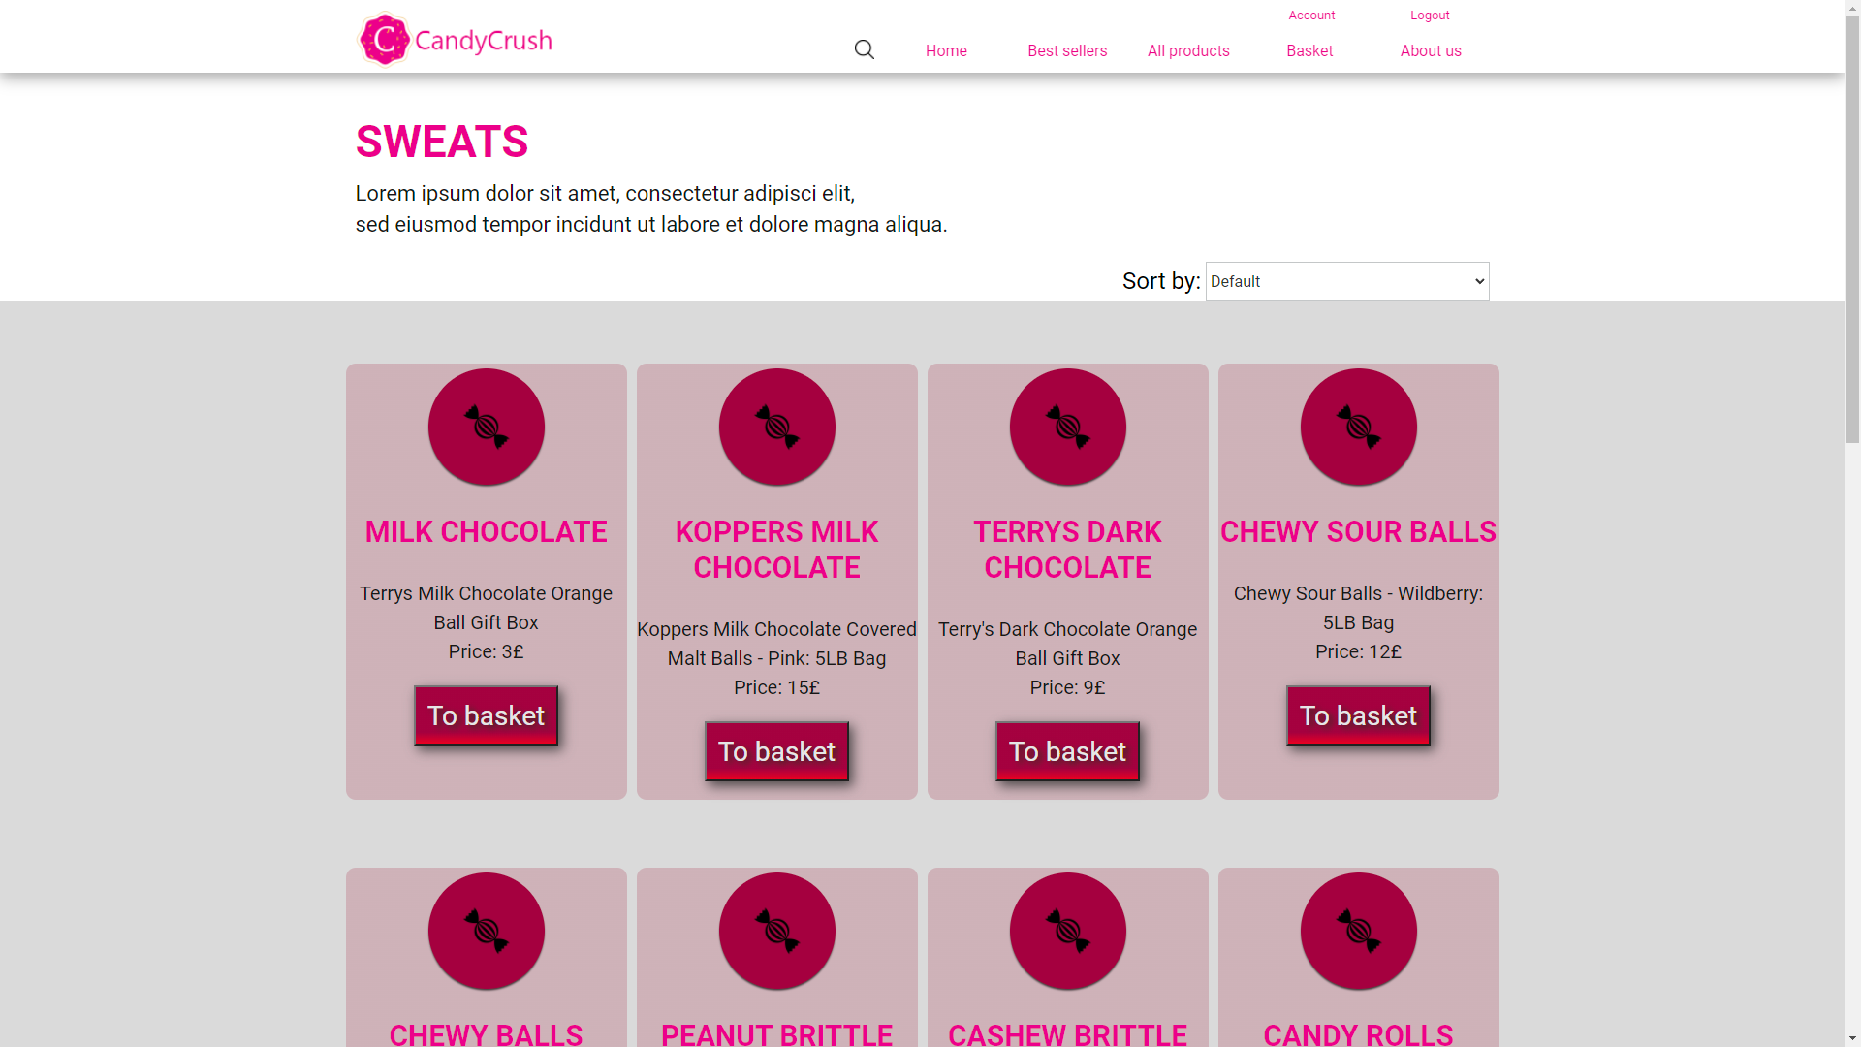

productpage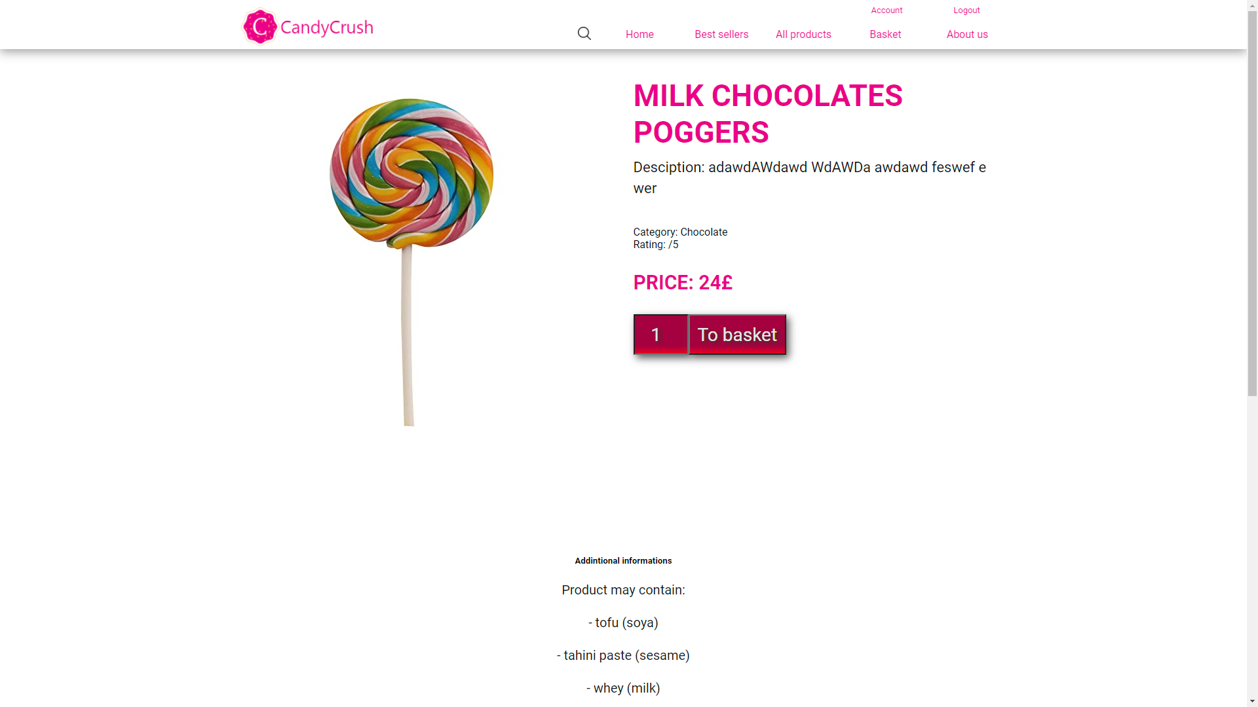

Basket: 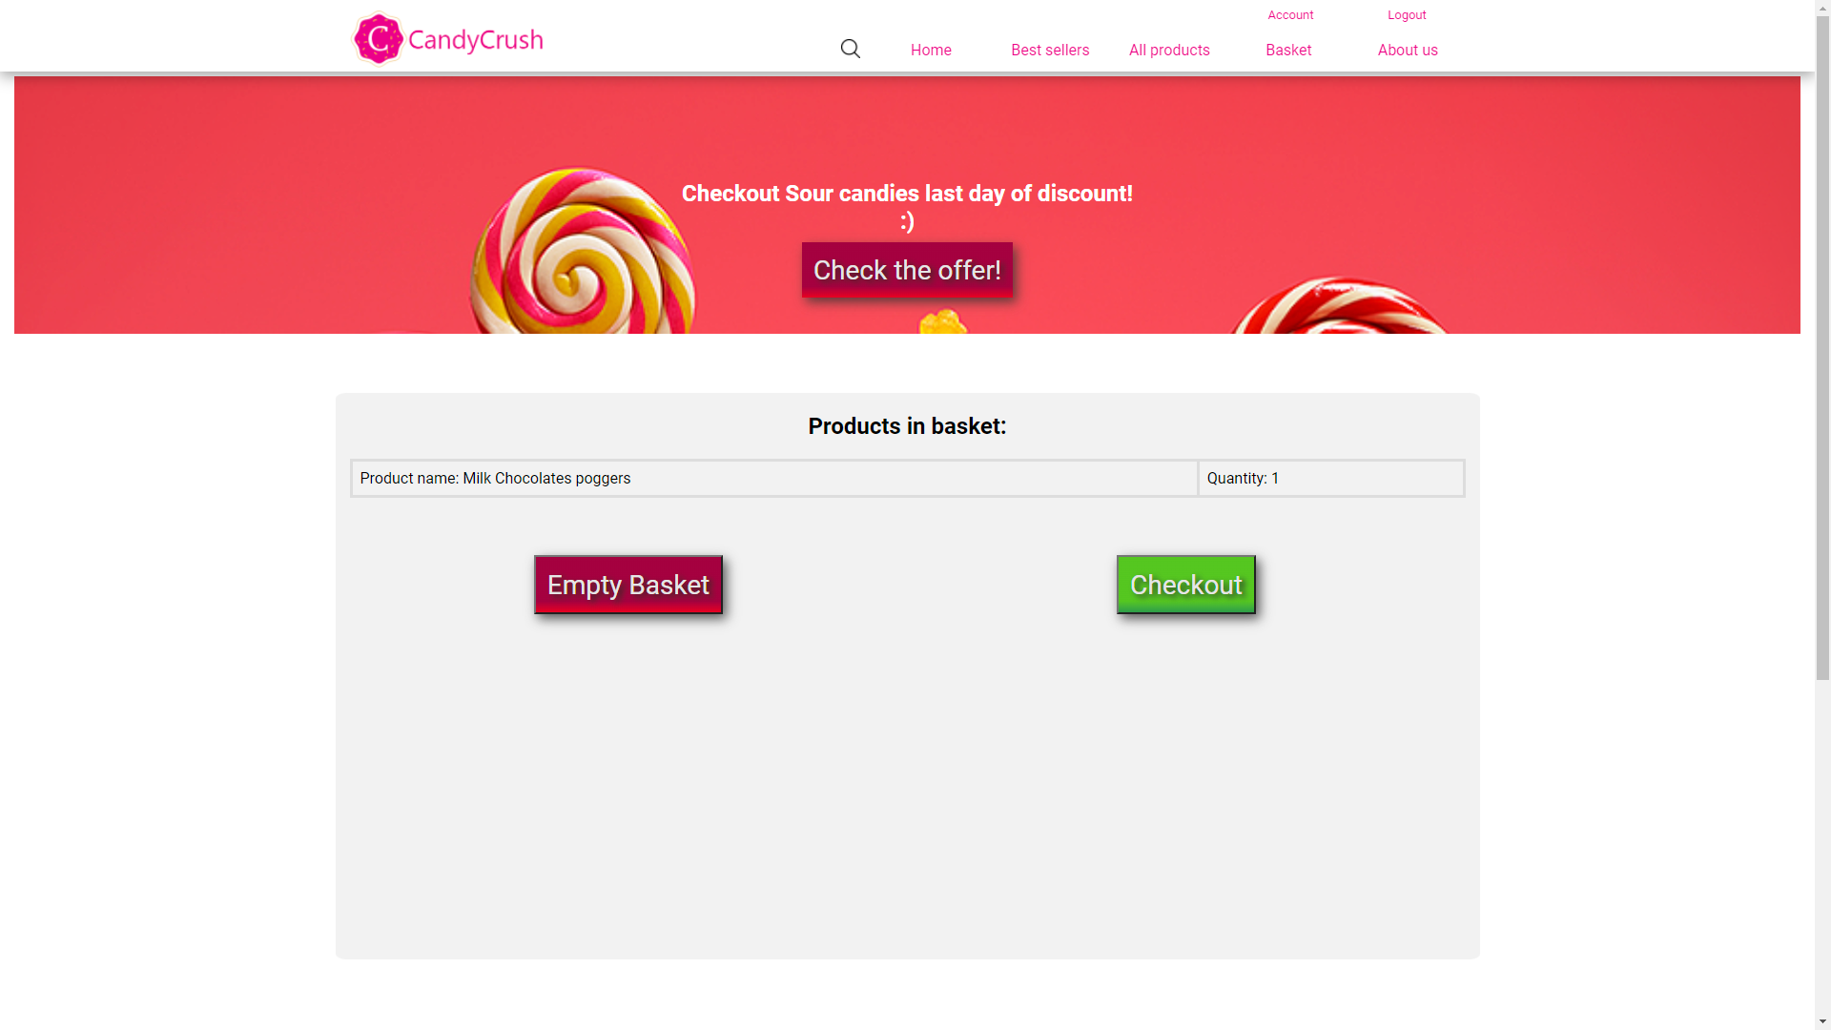

Checkout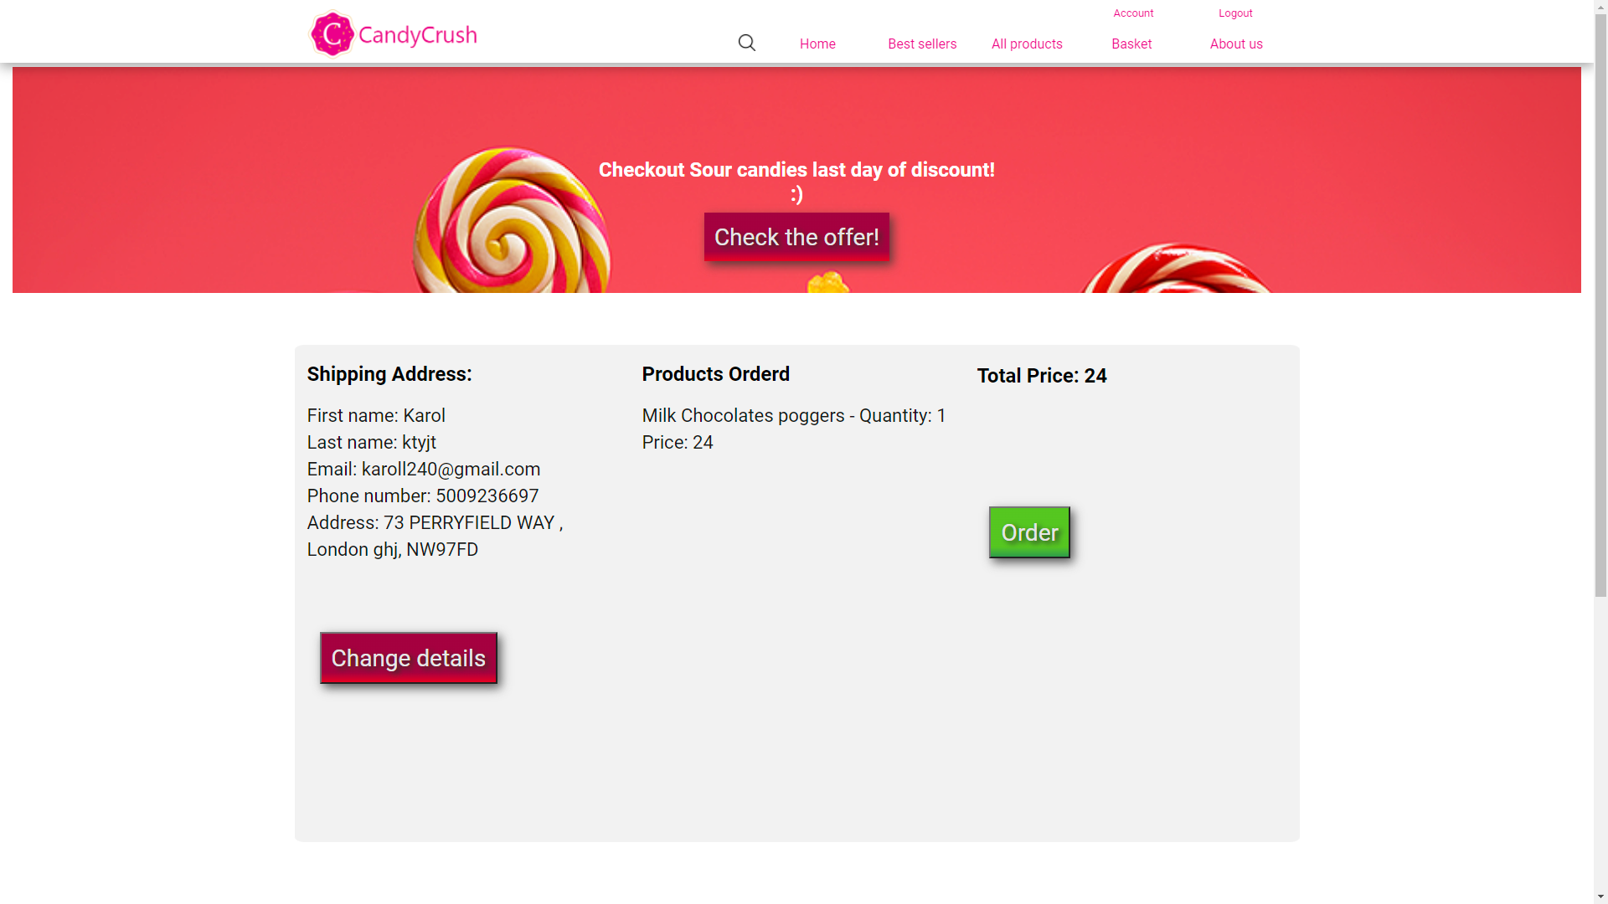

Account page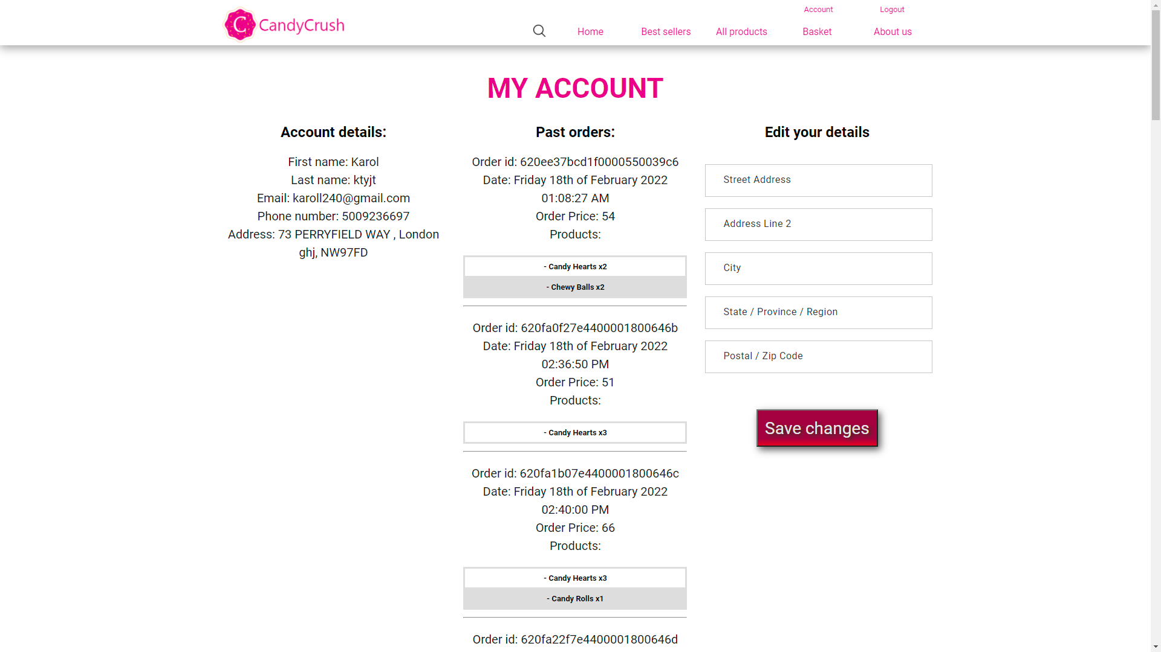

Before login: 

After login: 

CMS View products

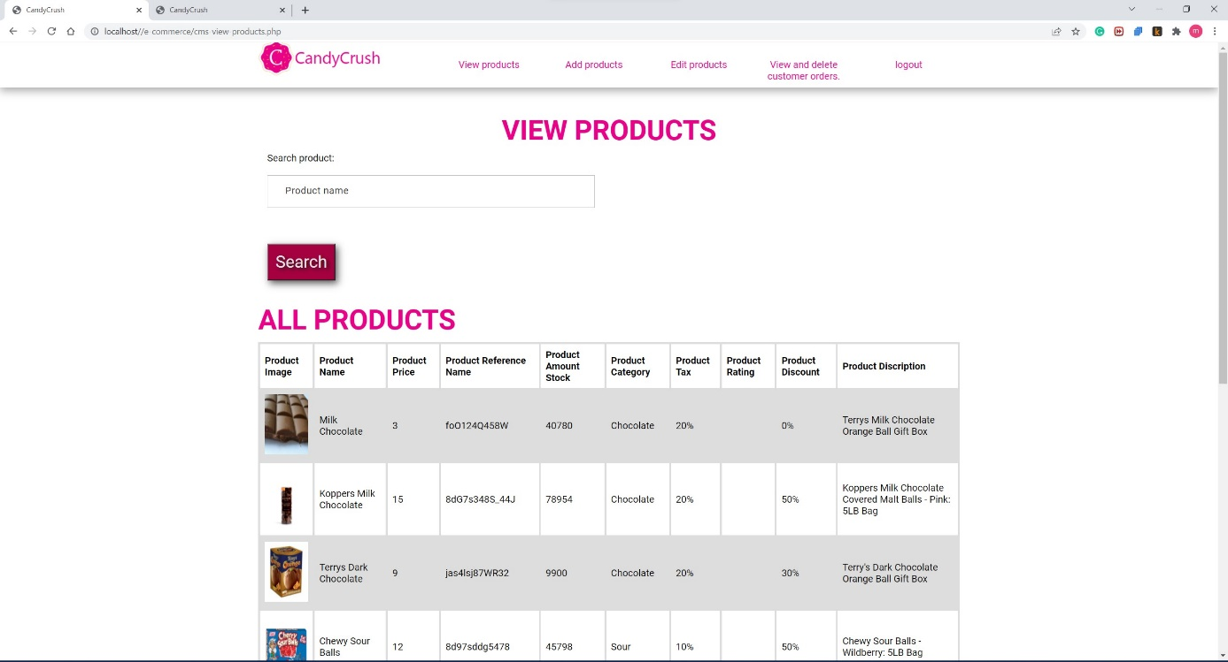

CMS View products

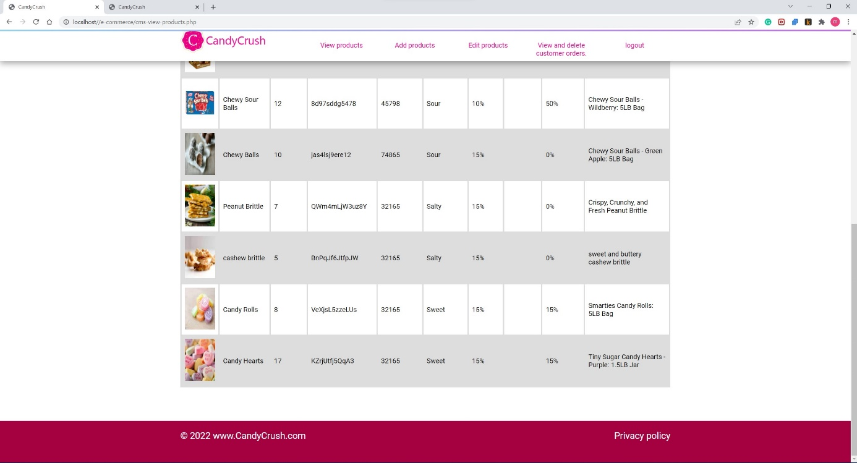

CMS Add products

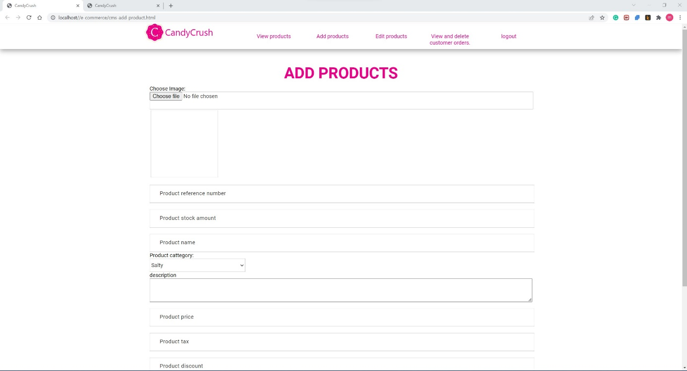

CMS Edit products

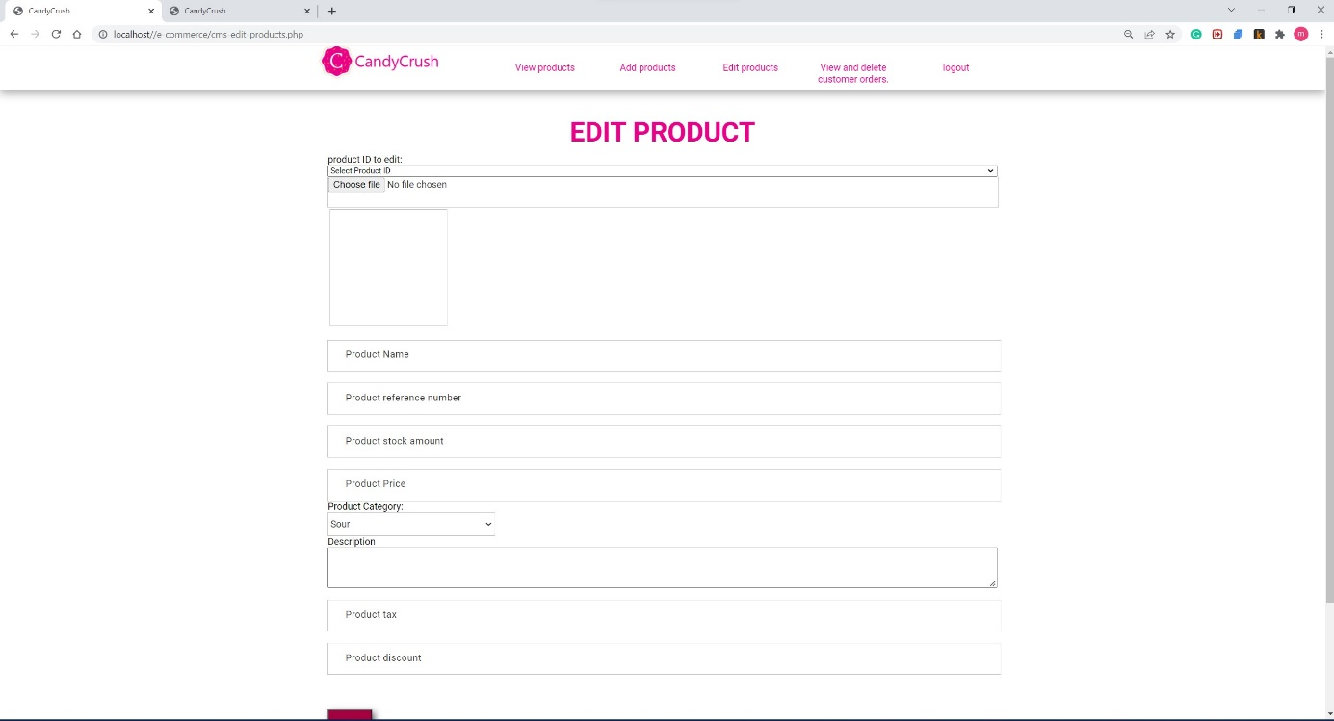

CMS Login page

